Chemical Control

Your body has a second communication system, which reacts more slowly than the nervous system. In this system, chemicals are the messengers and they travel through the bloodstream.

The endocrine system
Hormones are ______________________________________________________________
__________________________________________________________________________
They are produced in _________________________________________________________
___________________________________________________________________________
Together all these glands ______________________________________________________
The endocrine system is _______________________________________________________
It responds to information from _________________________________________________
___________________________________________________________________________
The hypothalamus constantly ___________________________________________________
___________________________________________________________________________

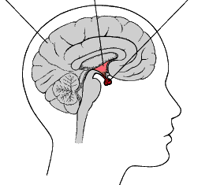
The Hypothalamus
The hypothalamus links ______________________
__________________________________________
__________________________________________

It secretes _________________________________
__________________________________________

The pituitary gland ___________________________________________________________
___________________________________________________________________________
How hormones work
Endocrine glands in the human body
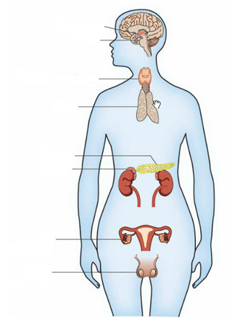
Hormones travel __________________________
________________________________________
________________________________________
________________________________________

Hormones are specific ______________________
________________________________________
________________________________________

Different hormones ________________________
_________________________________________
_________________________________________

Within cells _______________________________
_________________________________________

A hormone is ________________________________________________________________



